IN723 Lab 10 BGP RTBH Filtering – Destination Based

In this lab we will configure and investigate the use of Remotely Triggered Black Hole filtering using BGP’s ability advertise to advertise the next-hop attribute.
The lab primarily focuses on destination based filtering, though source based is covered in the lab extension.
Consider in this scenario that the Target router is under attack by a large DoS originating from the Attacker router. Using RTBH we are able to quickly implement a policy that will drop all traffic destined to the Target. The primary purpose of this action is to alleviate the collateral damage being caused by heavily congested links. This will give the provider time to more fully investigate the cause and implement additional policies targeting just the attacker possibly in conjunction with other upsteam peers / providers.
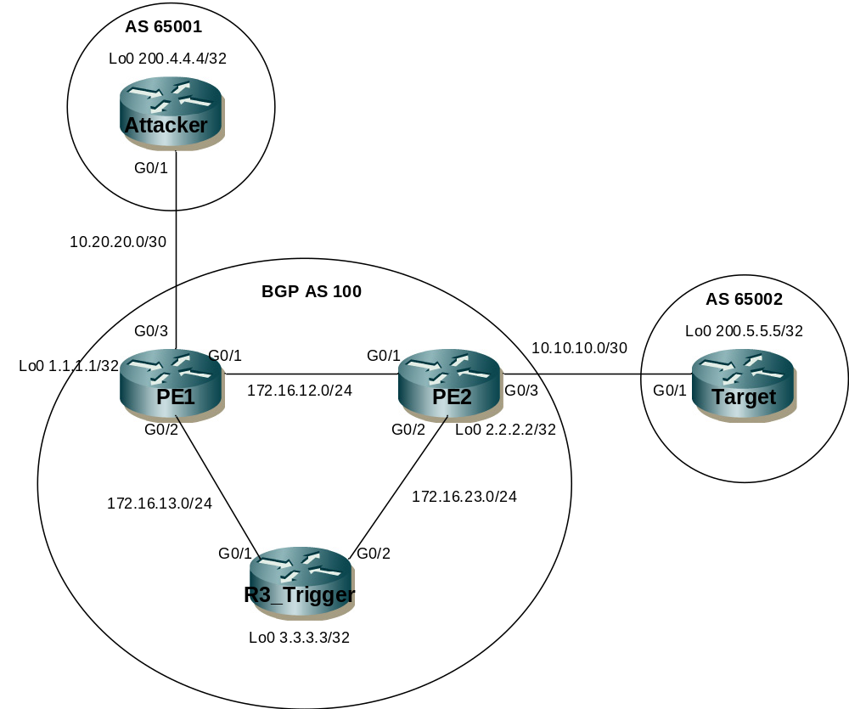

IP Adressing
Device | G0/1 | G0/2 | G0/3 | Loopback
PE1 | 172.16.12.1/24 | 172.16.13.1/24 | 10.20.20.1/30 | Lo0 1.1.1.1/32
PE2 | 172.16.12.2/24 | 172.16.23.2/24 | 10.10.10.1/30 | Lo0 2.2.2.2/32
R3_Trigger | 172.16.13.3/24 | 172.16.23.3/24 |  | Lo0 3.3.3.3/32
Attacker | 10.20.20.2/30 |  |  | Lo0 200.4.4.4/32
Target | 10.10.10.2/30 |  |  | Lo0 200.5.5.5/32

- This lab requires VIRL or GNS3 and ustilises routers to simlulate end hosts.
- This lab cannot be completed in packet tracer (unsupported BGP commands)
- You may need to clear BGP sessions or issue a soft reset for some changes to take effect

Step 1 - Physical
- Cable the lab as per the above diagram in VIRL using IOSv nodes.
- All devices are IOSv routers.

Step 2 – IP addressing
- Configure IP addressing as per the network diagram.
- Ensure to configure the loopback interfaces.

Step 3 – OSPF & iBGP Peering
- Configure OSPF area 0 between PE1, PE2 & R3. Configure the Lo0 IP addresses as router-ids. Advertise the Lo0 networks on each router.
- Configure BGP AS 100, no sync, no auto summary and fixed BGP router-ids on PE1, PE2 & R3 using the loopback 0 addresses
- Configure iBGP between each directly connected router as per the diagram. Use the loopback ip addresses for peering. Ensure all iBGP neighbor relationships are established.

Step 4 – Attacker and Target eBGP peering
- Configure eBGP peering between PE1 & the Attacker (AS 65001). Use the WAN ip addresses for peering. Configure PE1 with next-hop self for iBGP peers. Advertise the Attacker Lo0 via BGP using a network statement.
- Configure eBGP peering between PE2 & the Target (AS 65002). Use the WAN ip addresses for peering. Configure PE2 with next-hop self for iBGP peers. Advertise the Target Lo0 network via BGP using a network statement.

Step 5 – Prepare the routers for RTBH
- Configure a static route to null0 on PE1, PE2 & R3_Trigger. Use the 192.0.2.1 address from the test-net IP range (192.0.2.0/24).
ip route 192.0.2.1 255.255.255.255 null0

Step 6 – Prepare the Trigger
- Configure a route-map on R3_Trigger. The route-map will match routes with a specific tag value of 666. Ensure that the route-map will make matched routes the preferred path by setting the origin to igp and the local-preference to 200 (default is 100 and higher is better). Set the next-hop to the corresponding network that is routing to null0 on PE1 & PE2 (192.0.2.1). Set a community of no-export to ensure that the matched routes will not be readvertised.
route-map RTBH
match tag 666
set ip next-hop 192.0.2.1
set origin igp
set community no-export
set local-preference 200

- Apply the route-map to a redistribute static command on R3_Trigger.
router bgp 100
redistribute static route-map RTBH

Step 7 – DoS Traffic
- Confirm that the attacker can ping the target Lo0 address. Use an extended ping and set the source address as attackers Lo0 interface. You can leave it running with a continuous ping (or large number) to confirm the attack is suppressed in step 8.

Step 8 – Trigger the remote black hole filter
- Assume now that the Target device is under attack from the Attacker. We now add a static route to R3_Trigger and set a tag value of 666. The static route will be matched by the route-map attached to the redistribute static command. The route will be advertised to the PE routers with a next-hop IP that will resolve to a next-hop of null0.
- Note - the null0 specified here is not advertised. The actual next-hop advertised is that of the Trigger device’s peering address (10.20.20.2), however this is changed by the route-map to that of 192.0.2.1. The next-hop of 192.0.2.1 will then be resolved recusively on PE1 & PE2 to null0.
ip route 200.5.5.5 255.255.255.255 null0 tag 666

Step 9 – Verify
- Confirm the pings from the Attacker can no longer reach the Target.
- Use show ip bgp and show ip route commands on the PE routers to confirm the next hop is resolving to null0 for traffic destined to 200.5.5.5/32.

Extension – Source Based
- Configure Source based RTBH filtering.
- PE1’s link to the attacker will need to be configure for unicast reverse path forward – loose mode.

interface g0/3
ip verify unicast source reachable-via any

- Now you can configure a static on the trigger that matches the source address of the attacker (200.4.4.4). uRPF will verify the path to reach the source address for any packets received on g0/3. If there isn’t a path or it resolves to null0 it will be dropped.
ip route 200.4.4.4 255.255.255.255 null0 tag 666

